DULCE ET DECORUM EST

A Scripted 3v3 Map For Imperial Guard

By Titler and Incarnate
Poem and Title by Wilfred Owen

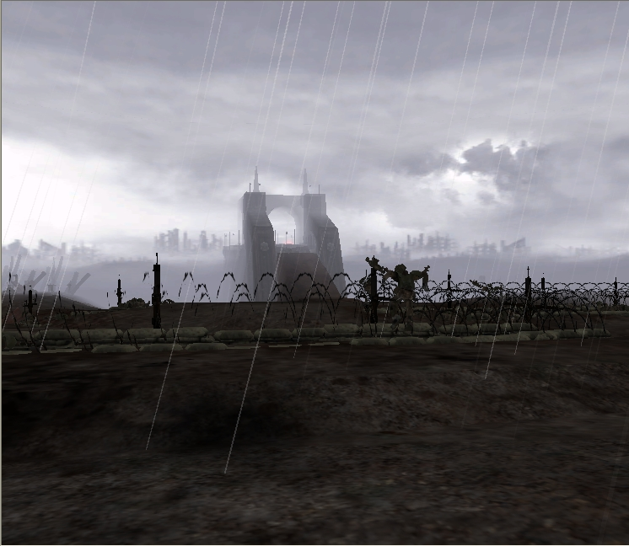

Before Starting The Map:

Please be aware “Dulce Et Decorum Est” is designed for 6 players in a 3v3 setting, and only for the Imperial Guard. Any player attempting to enter the game as another race will lose their initial HQ and starting units, but can still continue to fight from the remaining bunkers.

You may play as teams of less than 3, but settings such as FFA or 2v2v2 will not work as well due to the starting locations: The doomed Imperial youth are expected to rise from their trenches, go over the top, and into the cold dark embrace of No Man’s Land between the two lines.

If you wish to experience rain upon this map, you will need to set “FX Detail” under “Options” to Medium or above.

The differences between the Winter Assault and Dark Crusade installation of this map are relatively minor: The DC version has a different loading screen, to take advantage of the new team display, and a slightly modified SCAR file to remove Necron and Tau builders as well. Dark Crusade players also get that expansion’s extra unit, the Heavy Weapons Team, and the new Stealth and Unit Cap changes. Bonus units however can exceed this cap…

“Let not young souls be smothered out before
They do quaint deeds and fully flaunt their pride.
It is the world’s one crime its babes grow dull,
Its poor are oxlike, limp and leaden-eyed.
Not that they starve, but starve so dreamlessly;
Not that they sow, but that they seldom reap;
Not that they serve, but have no gods to serve;
Not that they die, but that they die like sheep.”
The Leaden Eyed,
by Vachel Lindsay.
The Scripted Features Of This Map:

When you begin the map, you will find you are unable to build anything, and your initial builder will pass away. You do start however with extra troops in the trenches, and reinforcements amongst the city.

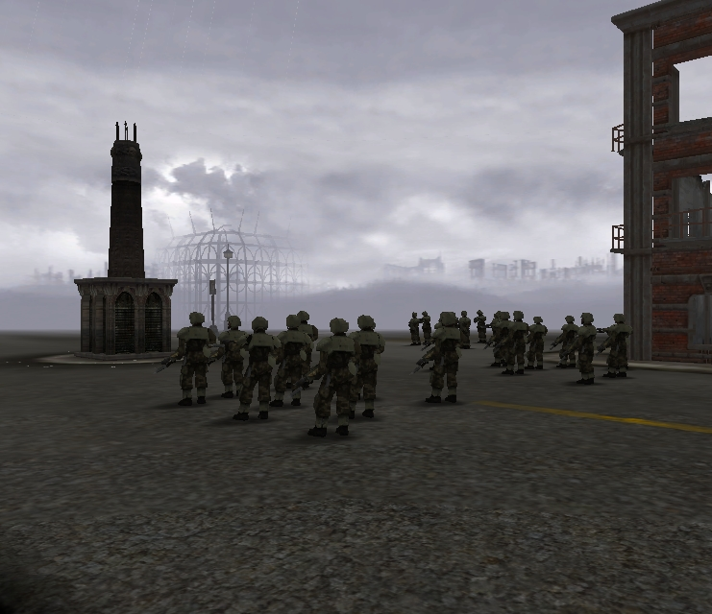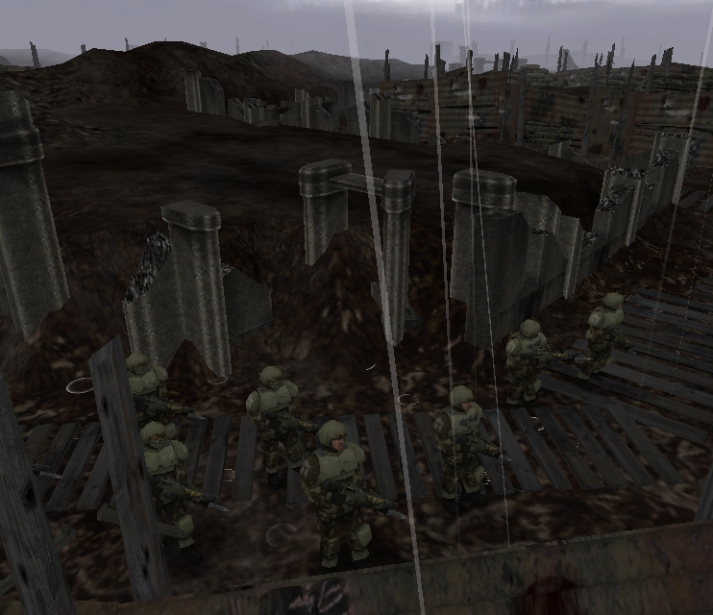

The troops in the trenches are scripted so that if you have Computer controlled players within the game, they will defend their front lines with those units, until they are eventually killed.

Also within the city you will find 2 pieces of artillery, fortified into immobile positions safely behind your own lines:

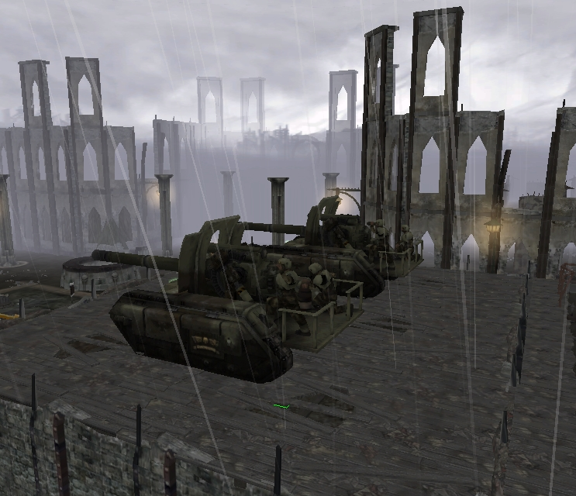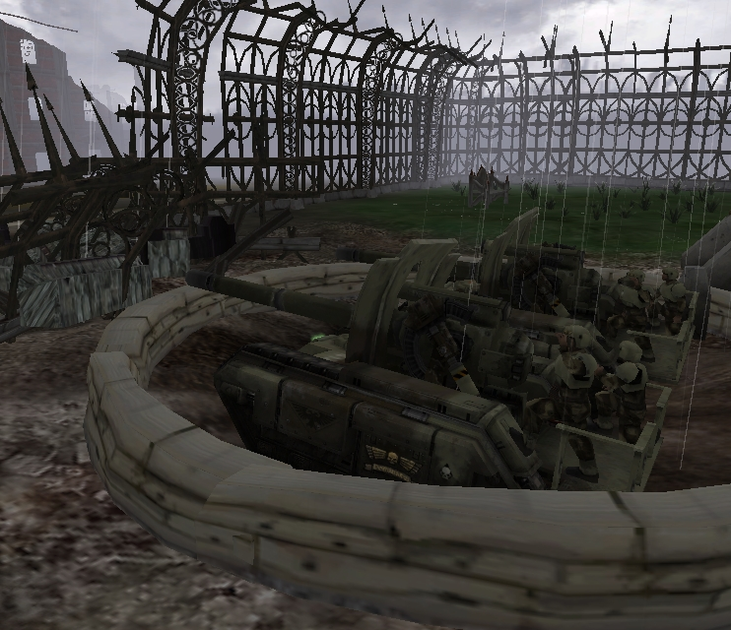

These are Special Basilisks, and have much greater range than normal artillery; enough in fact to strike the opposing front line trenches. Furthermore, whilst the players may use them manually to support their own coordinated Big Pushes, when left alone these guns will automatically make themselves useful. If they cannot fire upon a unit closest to them, they will seek to shell where opposing infantry were last seen, or rain suppression fire upon the central critical location.

“We are the Dead. Short days ago,
We lived, felt dawn, saw sunset glow,
Loved and were loved, and now we lie,
In Flanders Fields”
Extract From In Flanders Fields,
by John McCrae
Died Jan. 28, 1918
Inside the trenches themselves, you will find one normal Basilisk, whose actions remain entirely your responsibility: From its starting position, it only has the range to fire upon its own front lines, but this will prove useful straight away for the defensive amongst you. These are not fixed however, and the more aggressive will find that moving them up to join your brave lions as they charge forward will ensure that for your opponents, it’s all over by Christmas…

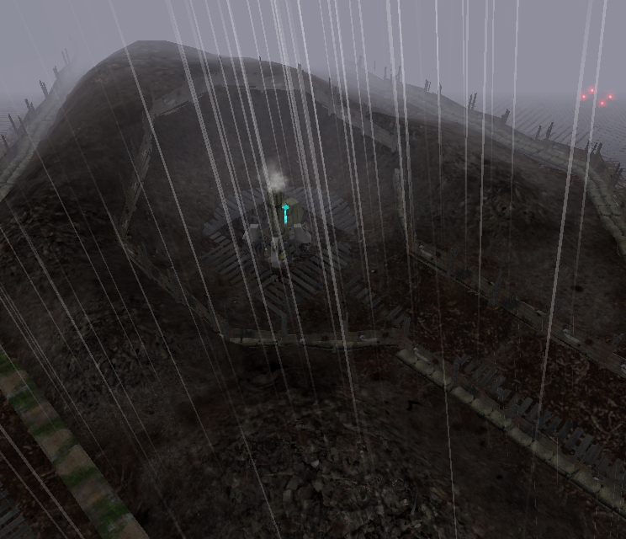
Amongst the mud and the carnage, you will find a number of battered battlefield features… These will give useful bonuses to the troops who hold them. To the left is an example of one of the unearthed slag pits: The first unit to approach these will claim it for their General back home, and it will continue to provide power for you until destroyed by an opposing force.
If one can survive long enough to cap the various high vantage points, not only will you gain more requisition for future troops, but you will also receive a subsequent increase in visibility across the wider conflict. In particular, fearless troops who wind their way up the narrow paths and take the central ruins will give to you the vision to rain much more accurate artillery fire upon your opponent’s front line trenches.
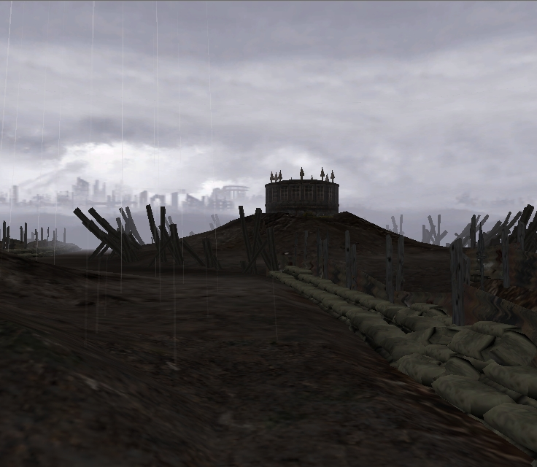

Furthermore, taking from your enemy the vantage points behind his own lines will give you the opportunity to shell him mercilessly further back, even where he was once previously safe. All it requires to take these tactical bonuses is that you summon the courage to charge across, and give him a taste of your cold steel.

“If I were fierce, and bald, and short of breath
I'd live with scarlet Majors at the Base,
And speed glum heroes up the line to death.
You'd see me with my puffy petulant face,
Guzzling and gulping in the best hotel,
Reading the Roll of Honour. `Poor young chap,'
I'd say -- `I used to know his father well;
Yes, we've lost heavily in this last scrap.'
And when the war is done and youth stone dead,
I'd toddle safely home and die -- in bed.”

Base Details,

By Seigfried Sassoon

But no matter how brave and wise your orders prove to be, not all of your muddy heroes can expect to come home alive: Fortunately however, the commanders behind the lines have taken the effects of being constantly pummeled by enemy shells into account, and will provide you with even more men and machines at suitable intervals.
The timer on the right of the screen indicates when you can next expect reinforcements, and when they arrive the mini map will indicate with red pings where they are waiting to be ordered forth from, to death or glory or both.

Each reinforcement wave increases the strength of the units arriving, until mankind’s finest, the Kasyrkin themselves, are deployed. Furthermore, each attack wave makes available a wider range of units for production at your Imperial HQ, and ultimately unlocks the Kasyrkin upgrade at the barracks too.
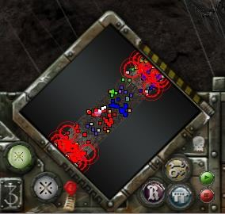

However, as the battle rages on, you can expect to find the available income to replenish your own chosen troops suffering from decay; And eventually, by fighting through the trenches and into the city beyond, one player will be knocked out of the conflict by losing his last bunker: Once this happens, the reinforcements waves will cease for all players after the next scheduled wave. Therefore, plan your attacks and where you choose to stand your ground well… In combat of such enormous scale, victory will go to the General who commands and co-ordinates all his man with the most efficiency and wisdom.

Further Map Information:

Trenches are all under Heavy Cover. Craters and enclosed areas (buildings) in general are light cover, unless there is a further sunken crater or area within them, which is then Heavy Cover. The central critical location is Heavy Cover within the dark stone, and Light on the slopes outside it. The water within the craters in No Mans Land is negative cover.

Don’t forget that you can use the tunnels connecting bunkers to move troops around quickly, but only 3 squads per bunker. This will help in avoiding your mass conscripts getting stuck places they shouldn’t, but will also provide an extremely useful tactical advantage if your team uses them to bring a reinforcement wave forward and your opponent is walking…

If you would prefer a more “No Mans Land” orientated battle, there are 5 Critical Locations on the Map, thus taking the central one will start the Take And Hold timer, assuming your team holds your own two, and will draw the fight there.

“My son was killed while laughing at some jest. I would I knew
What it was, and it might serve me in a time when jests are few.”
A Son
By Rudyard Kipling
(John Kipling Died 27th September 1915)
Map Parallels With The Real Trench Warfare Of World War One:

In so far as it is possible, we have tried to recreate the general outline of an actual WW1 battlefield within the Dawn Of War Engine. Namely:

- On the Western Front, the size of No Mans Land, or the average distance between the two opposing trenches was 100 to 300 yards. The distance between the two on this map is on average 140 yards.
- The front-most Trench was usually only lightly defended, due to the ability of enemy artillery fire to pound it, unless a major attack was incoming: As noted earlier, the fortified artillery behind your own lines can indeed strike the front lines of your opponent.
- As a consequence of the above, infantry would spend most of their time in a second defensive trench, known as the “Support Trench”, which would be 70 to 100 yards behind the first. On the above map, the average distance between the first and second lines is roughly 76 yards. Your first bunker sits on or by this Support Trench, ideal for hiding in if you so fancy…
- The third line of trenches would be 300 to 500 yards behind these two. Due to game play considerations - mainly the lack of fun in fighting along a single 300 yards long support tunnel - on our map it’s rather closer than this.
- Trenches expected to see combat in World War One would often look like this, dug down to just above head height, and then the excavated mud piled upon the sides for extra security:

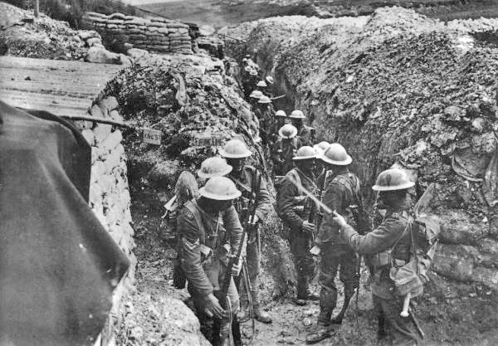

In Dawn Of War, Guardsmen are somewhere over 6 foot tall, so we have scaled our trenches’ depth to match their stature in turn: The trenches are as a result 2 metres (6’7”) deep, but to avoid ugly firing through the side mud above, we’ve banked the sides with sandbags and boarding instead. This we think looks more artistically pleasing when perforated by Guardsman weapons.

“The flowers left thick at nightfall in the wood
This Eastertide call into mind the men,
Now far from home, who, with their sweethearts, should
Have gathered them and will do never again.”

In Memorium
By Edward Thomas
Died April 9th 1917
- Further back, Trenches and Dugouts were 8 to 16 feet deep on the British side, and a minimum of at least 12 feet on the German side, but sometimes as deep as 3 stories down. However with DoW not taking Line Of Sight into account, the deeper you went into the ground the more awful it looked as Guardsmen regularly pumped the soil full of laser. Thus we chose a roughly uniform depth for all the trenches to maintain visual appearance
- We could not get very close to the actual real trench widths and combat mechanics alas. In World War One they were typically exceptionally narrow, no more than one or two men wide, and were exited by climbing ladders to charge over the top. In game terms, what this meant was that units would get stuck trying to pass each other in the narrow trenches, or tried to find ridiculous paths across the map in order to climb up or just walk around the small areas marked as passable beneath the ladders. This ensured not just that mass wave attacks simply didn’t happen, but that it was enormously frustrating to even play at all, due to 99% of your time being spent trying to micro the confused Guardsman away from each other.
So we had to fudge this a little: Vehicles would need wide ramps to leave the trenches from anyway, so we left these ramps as the main exit point for the Infantry too. Then we adjusted the travel paths of the units coming from the rear to the ramps so they would tend to use the vertical trenches, thus negating much travel horizontally across the trenches. This in turn allows you to place units into these small trenches as defenders, without having to worry too much about them jamming up your other units by being there.
- The “Square Tooth” layout of the trenches thus remains largely accurate to the real life layout of WW1 trenches: the average length of a bay on our map is a little larger to accommodate the big clumsy squads of Guardsmen, 25 yards or so as opposed to 10 yards long.
- “Sap” Trenches were single, probing trenches dug towards the opponents lines, which cut across No Mans Land to create listening posts, closer attack starting points, or to simply plant huge explosives: Sadly these kinds of dead end trenches don’t work in our virtual No Mans Land, as they physically cut the map in half. We have instead placed some examples of such utility trenches in the rear, as the starting place for your movable Artillery; They also make really handy spots for the artillery you get later on to park in too.
- Three quarters of deaths on the Western Front came from said Artillery fire. On the first three days of the battle of Verdun for instance, the French alone fired 3,000,000 artillery shells at the German lines. We had to tone our shelling down a little from there, to playable levels, but you should find it’s pleasingly merciless all the same.
- Likewise, we toned down the barbed wire in No Mans Land; In reality, there was so much of it that the Artillery was often employed for days before a Big Push hammering the wire just to try and blast paths through it… But indestructible scenery, and guardsmen with really, really big feet trying to squeeze through lots of wire make for unhappy Dawn Of War players.

"Iron are our lives
Molten right through our youth.
A burnt space through ripe fields
A fair mouth's broken tooth."
Extract from August 1914
By Isaac Rosenberg
Died April 1st 1918
The Map Makers Would Like To Thank:

Titler thanks all the people who have helped guide the map into its current state. In particular, Incarnate for taking up the call to script all the elements that were beyond me, and for patiently and constructively working on all the parts of the script (and his ideas for it) that I then proceeded to test to destruction.

To which ever fine artist produced the two custom Decals I made use of for this map, “marker_warning_corner” and “urban_rubble06”.

To the beta testers from the Relic boards, Argonought, RolfTheSlasher, Grabnutz, adamstrange, pigeonmafia, Carl, Cmdr_Rentsy, PikachuMarine, Tator Tot, PathosAngelos, Listoric, Ragnarok2504, and bloodthirster90. From the realm of the Mongbat, Lord Dahak and his incredible proof reading powers. And of course, anyone else I may have accidentally missed who may have provided useful feedback and help!

To Troubleshooter, Aralez, and Ragnarok2504 who laid down their Dark Crusade installs to find a bug with the installer during erroneous final release. Sorry guys…

Also thanks to The Horde of Khadgar, in particular Liwanu, DivineBovine, Takeda, Sourdust, and the rest of Tragically Optimistic for putting up with me boring them intensly in guild chat about another game entirely, but also for supporting me when Dulce Et, amongst other things, wasn’t working out quite how I intended it.

And finally, to those close friends whose concern and compassion has kept me sane over the past months; Ranjana, Vicky, and Sheri… Almost no one who reads this far will know who you are or how much you’ve helped, but no matter how many hours I’ve spent on this map, I do. Thank you.

Incarnate thanks all those over on relic forums who have made all this possible, without you I would never have come this far!
Argonought, without you I would never had the confidence to script such complex things. Whenever I had my doubts, I always knew that I could turn to your vast expanse of knowledge to find the solution to my problems. It is thanks to Argonought that I was able to code the artillery so that they worked online.
Cuttershane, it was from your code that I based the artillery off. Without your support services mod I would never have been able to understand SGroup_ForEach(), but from this now I will be able to code even more amazing things!
My thanks go out to all those on relic forums who have helped out and given me tips over the past months. Ruosteinen, BrSgt_Burns and FinalDeath have been some of the most helpful on the forum, and for this I thank you.
Relic; Thanks for the awesome game and the most simple of things; actually allowing us to mod the game!
Last but not least, my thanks go out to Titler. I apologise for the arduous torture I must have put you through. Not only did you have to put up with my scar jargon, you also had to put up with me ☺

“War's a joke for me and you,
While we know such dreams are true.”
Extract from “A Letter Home (To Robert Graves)”
By Siegfried Sassoon

Dulce Et Decorum Est

Bent double, like old beggars under sacks,
Knock-kneed, coughing like hags, we cursed through sludge,
Till on the haunting flares we turned our backs
And towards our distant rest began to trudge.
Men marched asleep. Many had lost their boots
But limped on, blood-shod. All went lame; all blind;
Drunk with fatigue; deaf even to the hoots
Of gas shells dropping softly behind.
Gas! Gas! Quick, boys! – An ecstasy of fumbling,
Fitting the clumsy helmets just in time;
But someone still was yelling out and stumbling,
And flound'ring like a man in fire or lime . . .
Dim, through the misty panes and thick green light,
As under a green sea, I saw him drowning.
In all my dreams, before my helpless sight,
He plunges at me, guttering, choking, drowning.
If in some smothering dreams you too could pace
Behind the wagon that we flung him in,
And watch the white eyes writhing in his face,
His hanging face, like a devil's sick of sin;
If you could hear, at every jolt, the blood
Come gargling from the froth-corrupted lungs,
Obscene as cancer, bitter as the cud
Of vile, incurable sores on innocent tongues,
My friend, you would not tell with such high zest
To children ardent for some desperate glory,
The old Lie; Dulce et Decorum est
Pro patria mori.

By Wilfred Owen
Died November 4th 1918.

“Sweet And Right Is It, To Die For Your Country”

